**Recap on previous labs**

By now, you should be familiar with the following:

1. Create html files using an editor and define them as HTML5 documents.
2. Understand the basic structure of an HTML document.
3. Paired tags such as <p>.
4. Self-closing tags such as <br />.
5. Variety of html elements and attributes.
6. CSS as follows:
   1. Create styles (internal and external)
   2. Apply styles
7. Define different layouts
   1. Use of # to define ids eg.  
      #header{background-color:#CCFF66;height:150px;}
   2. Use of <div> to apply an id to elements within the html file eg.  
      <div id="header">  
      <h1>HEADER</h1>  
      <div="nav">
8. Use of new HTML5 elements for structure such as:
   1. <article>
   2. <header>
   3. <section>
   4. <footer>
   5. <nav>
9. Upload files AND folders to a remote server and able to preview these web pages (including multimedia) using a URL instead of a local path.

**Assessment**

At this stage, you should have uploaded your first assessment. You can add more pages and features to it so that it is now your second assessment.

**Week 8**

**Validation**

1. Open the url for validation of HTML5 files in a browser: [validator.w3.org](http://validator.w3.org)
   1. Choose the ‘Validate by File Upload’ option
   2. Browse to an html file from an earlier lab eg week 3 files (table, form, multimedia)
   3. Choose the ‘Check’ option
   4. Check the results. You may get warnings or errors or both. A good result is a green bar displayed as follows:

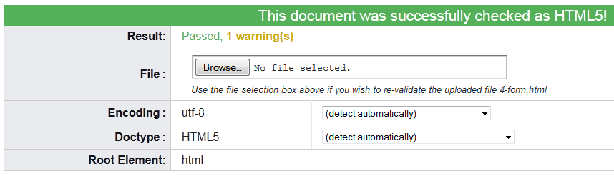

* 1. If you get a red bar then read the information about the errors and try and correct them within the html code and revalidate the file again.
  2. Check the validation of other html files.

1. Open the url for validation of CSS files in a browser: jigsaw.w3.org/css-validator
   1. Choose the ‘By file upload’ option
   2. Browse to a CSS file from an earlier lab eg week 4 (mystyle.css)
   3. Choose the ‘Check’ option
   4. Check the results. As before, a good result is a green bar displayed as follows:

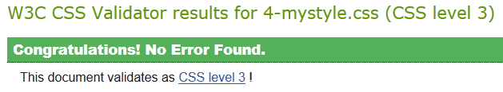

* 1. If you get a red bar then read the information about the errors and try and correct them within the css code and revalidate the file again.
  2. Check the validation of other css files.

**Forms - new types, elements, attributes**

1. Download the sample files from Moodle.
2. Open the file ‘1-new_form_input_types’ and look at the code for the new types such as:
   1. color
   2. date
   3. email
   4. number
   5. range
   6. url
   7. date-time
3. Open the browsers Mozilla Firefox and Google Chrome and open the file in both browsers. Resize them so that you can preview the files in both browsers at the same time. Note the difference in support for the different types:
   1. Which browser displays the date type as a mini calendar?
   2. What happens in each browser when you enter an invalid email address (eg one without an @ symbol) and try and submit?
   3. What happens when you type an invalid number for the year of course?
   4. Make some changes to the ‘.html’ file and preview these in a browser.
   5. Close the file, saving any changes.
4. Open the file ‘2-new_form_elements’ and look at the code for the new elements datalist and output.
   1. Preview the file in different browsers again to see the different levels of HTML5 support.
   2. What happens in each browser when you click in the data list box?
   3. What happens when you type a letter?
   4. Try different letters.
   5. Enter numbers with 2 decimal places into the input fields. What is the result?
   6. What happens when you use the arrows to change the value of the input numbers?
   7. Check the code. What is the parseInt function doing?
   8. Make some of your own changes to the values of the options in the ‘.html’ file and preview the file again in the browsers.
   9. Make changes to the function which does other calculations to the numbers in the input fields.
   10. Close the file, saving any changes.
5. Open the file ‘3-new_form_attributes’.
   1. Look at the new attributes such as:
      1. autocomplete
      2. autofocus
      3. placeholder
      4. multiple
      5. max
      6. min
      7. pattern
   2. Preview the ‘.html’ file in different browsers and note what the different attributes actually do.
   3. Add some new elements to the file and apply some of these attributes to them and preview the changes in a browser.
   4. Close the file, saving any changes.

**Graphics**

1. Download the ‘dog’ files from the images folder on Moodle. Look at the different formats ie png, jpg, bmp, giff.
2. Open them in an appropriate photo viewer and compare the sizes and quality of these files in different browsers.
3. Open the files ‘svg.html’, ‘svg_shapes.html’ and ‘svg_shapes_attributes’ and look at the code for the different shapes.
4. Preview the file in different browsers again to see the shapes. Try and work out how the coordinates are calculated from the values of the different attributes in the ‘html’ file.
5. Make some changes of your own and preview these in a browser.
6. Close the files, saving any changes.
7. Open the file ‘canvas.html’ and look at the code inside <canvas> element.
8. Look at <script> element which has some Javascript code to create a basic canvas on a web page. Don’t worry about the JS code as this will be covered in a later class.
9. Preview the file in different browsers to see how <canvas> element is supported and then close any open files.
10. Now, go back and open other files from earlier labs and incorporate some of these new features into them.